Eating In And Out During CoVid-19

Group 1 (Roméo, Patrick, Benedikt, Sofianna, and Ha Anh)

General Information:

The people, who participated in this survey were from 10-18 years old. 36% of them were from ages 10-14; 64% were 15-18 years old. The total number of participants was 249 people, but the interpretations were from the last 100 people who answered the survey.
Interpretation of all the answers:

We created this survey in a way that every question can be combined to get one interpretation on the general topic, which was “Eating in and Out During CoVid-19". Inserted below are the most important and relevant of the questions, for which we each created a graph; either bar charts or pie charts were used. The general conclusion of the survey is that most people did not change their eating habits; however, the eating habits about having food in a restaurant drastically changed. This is, for the most part, due to the lockdown and corona measures. We expected that most of the people would try new foods during the lockdown, but this was not the case. Most people didn’t change their food habits during and because of the lockdown(s). The responses to the question about how the eating habits changed, are quite clear. We see once again that most people didn’t change their eating habits at all. Only a small fraction had eaten more junk food during lockdown, which surprised us. In total, more people ate healthier than the people that had junk food. This means, that people were not as lazy during corona as expected, because preparing healthy food takes more time and effort than ordering junk food which gets delivered to your doorstep.
Expectations:
I expected that most people would eat more junk food, which was not the case. More than half the people who took part in the survey did not change their eating habits. Lots of people also ate more healthily and only one eight of the candidates ate more junk food. I expected in question two that more people would let a family member prepare food for them. This wasn’t the case as I saw when the answers came. What I also thought would happen was that more people would order food. I didn’t really expect that going out would have too many answers because of the pandemic because the restaurants were closed.
One of the expectations I had was that people used to go out more often, maybe on a weekly or monthly basis, before corona came. This proved out to be true because before corona the majority went to restaurants monthly; now, after the lockdowns have ended, the majority (almost) never goes to restaurants.
My expectation was that more people would let one of their family members prepare food for them, but I was wrong. Only 40% let family members prepare food for them which isn’t that much. I thought that more people would go out and eat food in restaurants which clearly people don’t do that much, this may be because of the Corona Virus pandemic and the lockdown(s). What I did not see coming was that so many people like cooking their own food.
The graphs to the results of the 5 most important Questions and the individual Interpretations:
What do you personally prefer from the options given?
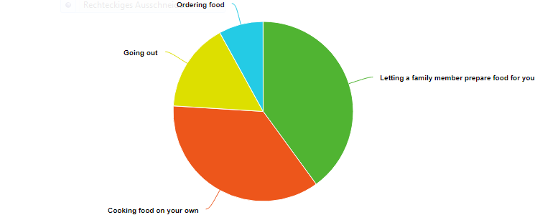

Letting your family member prepare food for you-----40%
Cooking your own food-----36%
Going out-----16%
Ordering food-----8%

Most people let one of their family members cook for them. I think this is because it’s the easiest. But then again really many people like cooking their own food instead of letting someone prepare it for them. Going out has very little answers this may be because of the Corona Virus and the restaurants closing. The least number of answers was ordering food, I think this is because ordering food is quite expensive and costly if you do it regularly.

How often did you go to restaurants before corona?
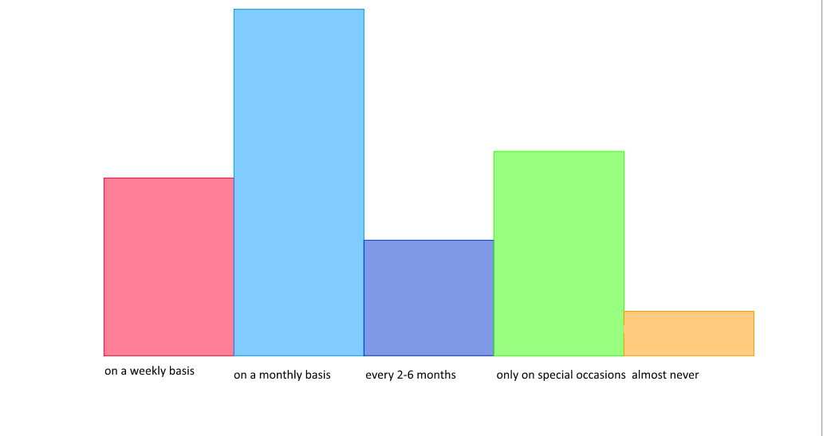
On a weekly basis (20%)
On a monthly basis (39%)
Every 2-6 months (13%)
Only on special occasions (23%)
(almost) never (5%)
Most of the people go to restaurants regularly. Only a few go to restaurants almost never. I believe the people that almost never go to restaurants do so because they like to cook food themselves.

How often did you go to restaurants after they reopened? (Still during corona!!)

On a weekly basis (22%)
On a monthly basis (17%)
Every 2-6 months (12%)
Only on special occasions (21%)
(almost) never (28%)

Before corona, one could clearly see that most of the participants of the survey went to restaurants monthly (39% of the people). That number clearly got less after the lockdown because the number of people going to restaurants monthly after the restaurants reopened sank to only 17%. This shows that after the lockdowns people are more careful about going out due to corona. Another reason why people go to restaurants less could also be because the lockdowns could’ve changed their preferences of eating habits, and that they may be like eating and cooking at home more nowadays.

Did you try new types of food lately, and did the lockdowns have an impact on this?
Yes, I tried new types of food because of the lockdowns (33 of 100 answers)

Yes, I tried new food during, but not because of the lockdowns (32 of 100 answers)
No, I didn’t try new types of food because or during the lockdown (35 of 100 answers)

Most people said that they didn’t try new types of food because of or during the lockdowns. This could mean, that not a lot of people were encouraged to try new foods, but could also mean, that people were too lazy to get out of their comfort zone or had no encouragement to do so. The second largest group is the group with the answer: Yes, I tried new types of food because of the lockdowns. This also means, that the people that tried new foods have had more time or more encouragement through family, friends or even through companies and their advertisements. The last and smallest group is the group that did try new types of foods, but not because of the lockdowns.

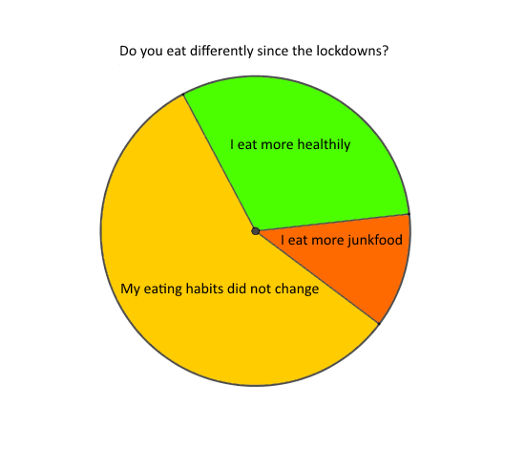
31% I eat more healthily.
12% I eat more junk food.
57% My eating habits did not change.
Most people did not change their eating habits. Little people ate more junk food, but it had a neutral to good effect on everyone. I think this is because students had more time to prepare their own food, which is healthier than premade food. Some ate more junk food because there was so much at home, and they just couldn’t resist.
Summary:
With our survey, we (as a group) wanted to know what people’s eating habits were, and if, why, and how they changed. We are all different people, and all five of us, already have different food preferences; some of us like to order food; others cook on their own; and two of us prefer letting our family members prefer food; so we thought about asking children who were approximately our age to participate in our survey, so we could find out about each person’s eating preference. Each of us had different expectation to the answers that were then selected; some of them proving to be right; others coming out as the total opposite of our expectations.

