HANDS TOGETHER EARTHQUAKE RECOVERY PLAN
PHASE 1- STABILIZATION, HOPE, BASIC NEEDS
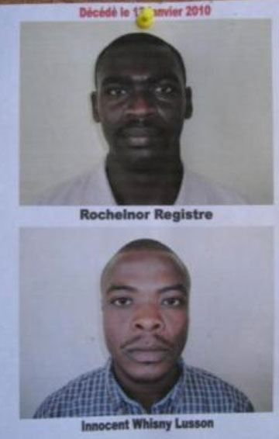
Our damage and loss assessment is ongoing and with each new day we are learn of the dead, injured, and homeless among the Hands Together students, staff and family. Many families have left Port-au-Prince to stay with relatives in the provinces and others migrated to nearby tent cities. Already, we’ve learned that several students and staff perished. Our Phase 1 (1-3 months) recovery activities include:
- Remove the debris from our destroyed headquarters on Delmas 31, locate the two Oblate seminarians who died underneath the rubble, and bury them behind our house.

Oblate volunteers who perished in the quake
- Salvage anything usable including food, furniture, office equipment and files and establish a safe base for storage and operations.
- Establish communications (phone and internet), repair vehicles, secure diesel fuel, and stockpile drinking water at our base.
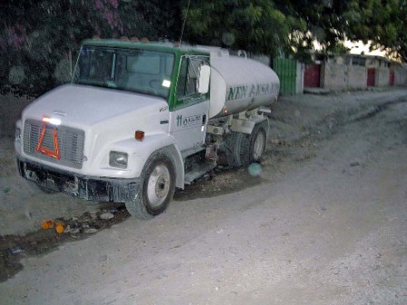
- Secure storage at a local depot for food, donated goods, and supplies.
- Deliver water daily to the people at all school campus locations.

HT Water Truck saving lives
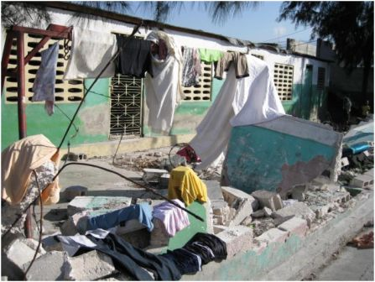
- On January 22nd we created “leadership teams”– led by captains and utilizing the staff and workers from our schools and the surrounding communities. These teams oversee outreach activities such as water and food distribution, clean up and rebuilding and community work, at each 8 zones in Cite Soleil and Delmas.
- Build temporary walls around our campuses and conduct food and supply distributions.

St. Joseph campus earthquake damage

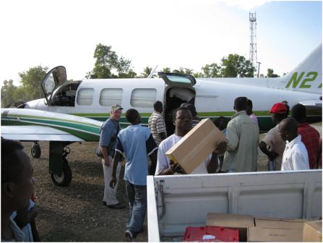
- Partner with Mary’s Meals from Scotland to provide food, shelter, and emergency cash grants to families in greatest need.
Fr. Tom unloads medical supplies for the hospital in Hinche.
Our dear friends from Scotland, Mary’s Meals, flew in this cargo plane
filled with valuable meds for the hundreds of earthquake victims
that were bused to Hinche Hospital.
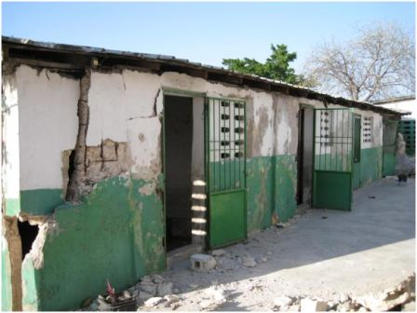
- Assess the physical condition of our eight Becky DeWine school campus buildings and create a demolition and rebuilding plan.
St. Jane Chantal campus – every wall and building suffered severe damage.

- Provide small grants for home repair or rebuilding.

