HANDS TOGETHER EARTHQUAKE RECOVERY PLAN
PHASE 2 – REBUILDING, TEMPORARY SCHOOL, EMPLOYMENT
Through our Phase 1 recover plan we hope to instill hope and encouragement and demonstrate our commitment to help our students, staff, and the communities of Cite Soleil. Phase 2 is a work in progress. Much depends upon the large scale rebuilding plans of the big agencies. We want to inject some normalcy into the community by restoring some of our education and nutrition programs. Rebuilding our school campuses and providing homes for people will be a high priority, as these activities will also produce jobs for many Cite Soleil residents.
Our Phase 2 (3-12 months) activities include:
- Continue to provide medical services, food, and water to those in need.
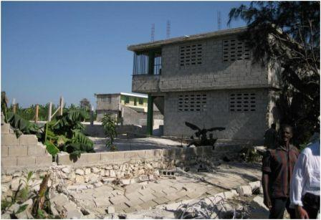
- Construct temporary classrooms with corrugated tin or tents and begin a “barefoot school” program, providing food and 1-2 hours of instruction.
- Build and repair homes for all HT (=Hands Together) staff needing assistance.
St. Franswa Campus- showing most of the perimeter wall collapsed.
The buildings suffered major structural damage.
- Construct new HT headquarters.
- Create plans and identify resources for permanent classrooms to replace those that were destroyed in the earthquake.
- Develop a longer-term project priority list to help us identify how resources can be used most effectively to provide food, shelter, water, and medical care to those in most desperate need.

